Table of Contents

Steps For Structure from Motion. 4

Intermediate Step Results 4

Key Points Found before applying homography 4

Key Points Match After Applying Homography 5

Number of KeyPoints 5

Epipolar Lines 5

Essential Matrix 6

How to find the exact Rotation and Translation matrix? 6

Rotation Matrix 6

Translation Matrix 6

Rotation and Translation Matrix stacked together – Horizontally. 6

3D Plots 7

Right side Camera (View 1) 7

Right Side Camera (View 2) 7

Left Side Camera (View 1) 8

Left Side Camera (View 2) 8

Top View 9

Center View 9

My Comments 9

References Used 10

Code (with step wise comments) 10

# deepika:Users:deepika:MyStuff:CSCI 677:Submissions:Assign4:Flowdiagram.jpeg

# Steps For Structure from Motion.

# Intermediate Step Results

# Key Points Found before applying homography

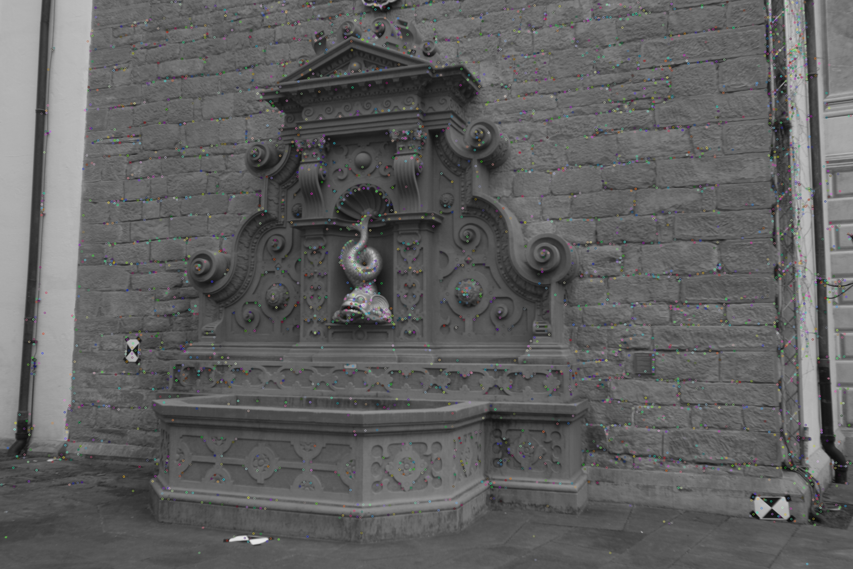

# Key Points Match After Applying Homography

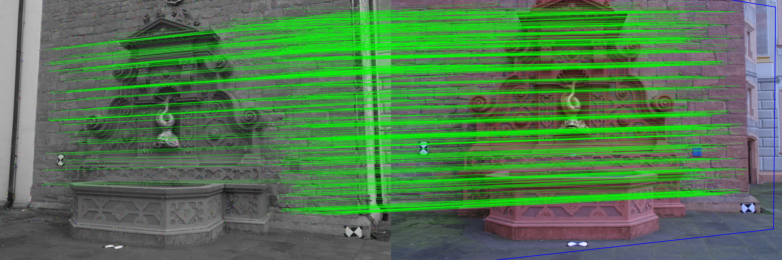

# Number of KeyPoints

4617

# Epipolar Lines

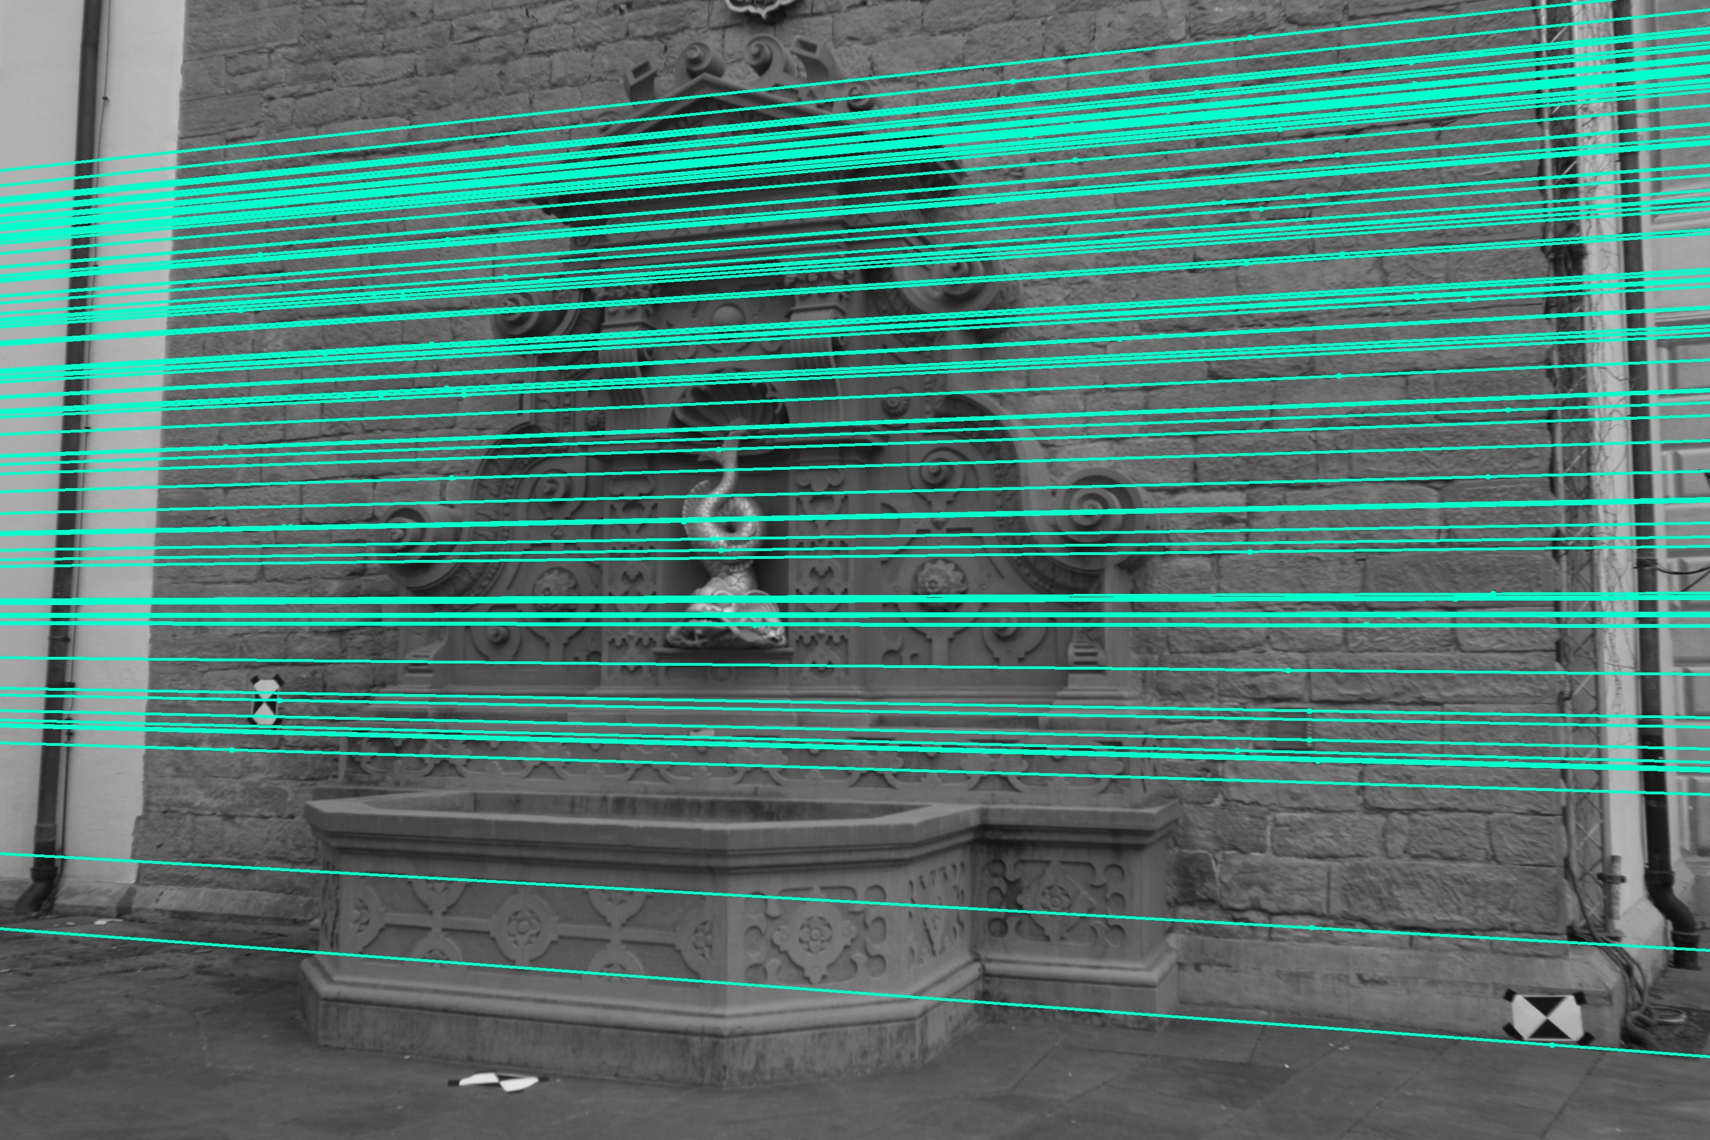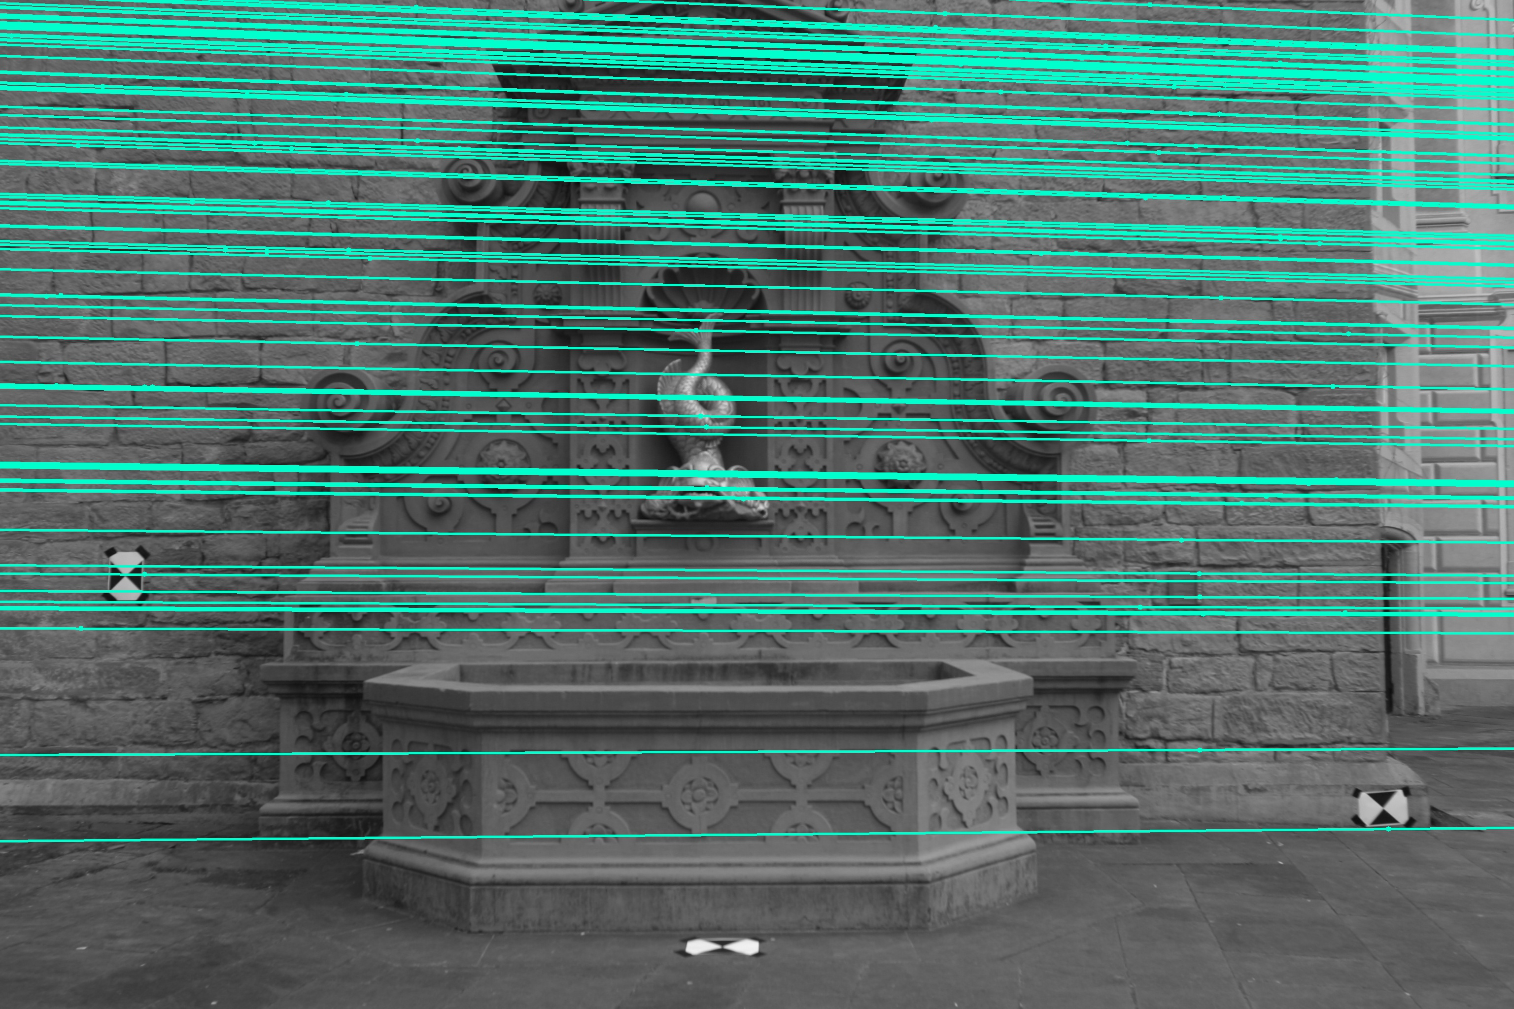

# Essential Matrix

[ [ 0.06830577 0.53381523 -0.1486675 ]

[-0.68842412 -0.01992625 -0.13473866]

[-0.0545068 0.41682117 -0.13814262] ]

# How to find the exact Rotation and Translation matrix?

So once we perform SVD on essential Matrix(E) using numpy function linalg such that we get three components such that E = USVT

Rotation and Translation matrix may be given as any of the following 4 options:

Option 1

R = U.dot(W).dot(VT)

T = U[:, 2]

Option 2

R = U.dot(W).dot(VT)

T = - U[:, 2]

Option 3:

R = U.dot(W.T).dot(VT)

T = U[:, 2]

Option 4:

R = U.dot(W.T).dot(VT)

T = - U[:, 2]

On comparing the good matches found with all four above mentioned options, by plotting them on 3D visualization graph, Option 2 was the best available.

# Rotation Matrix

[[-0.88668161 0.22582744 0.40348196 ]

[-0.05159609 -0.91549294 0.39901194 ]

[-0.45949273 -0.33297846 -0.82340256 ]]

# Translation Matrix

[[ 0.61363441 0.12264312 -0.78000736]]

# Rotation and Translation Matrix stacked together – Horizontally.

[[-0.88668161 0.22582744 0.40348196 0.61363441]

[-0.05159609 -0.91549294 0.39901194 0.12264312]

[-0.45949273 -0.33297846 -0.82340256 -0.78000736]]

# 3D Plots

## Right side Camera (View 1)

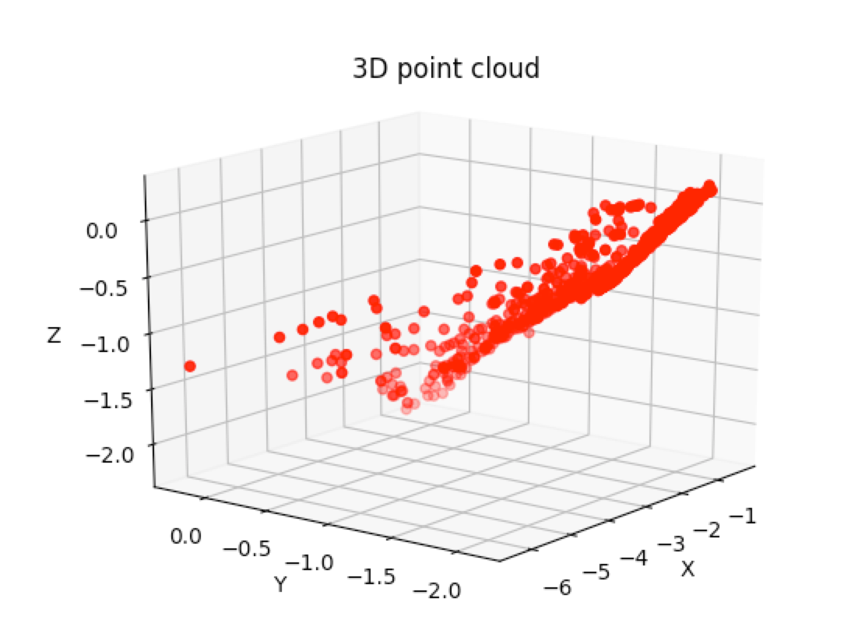

## Right Side Camera (View 2)

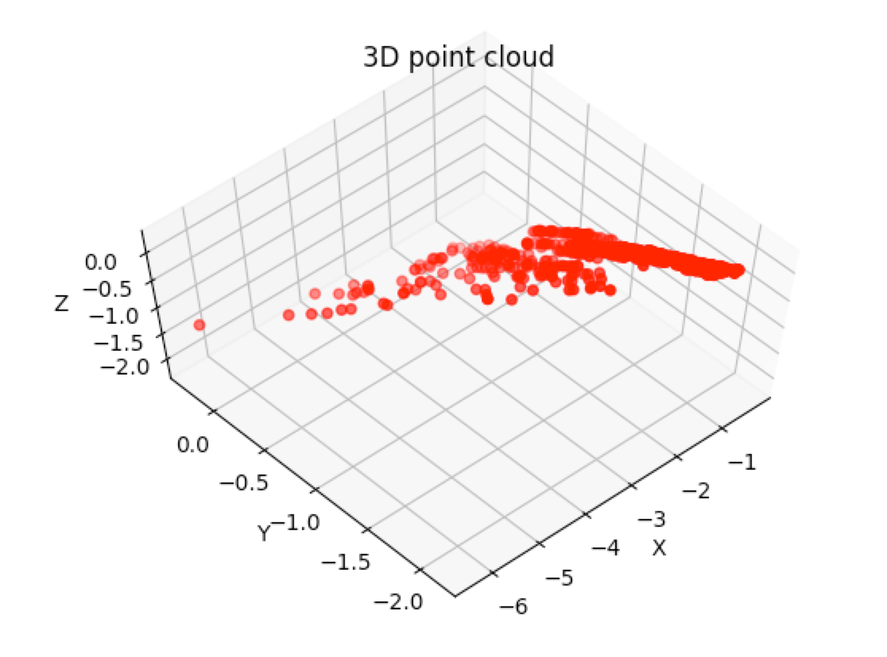

## Left Side Camera (View 1)

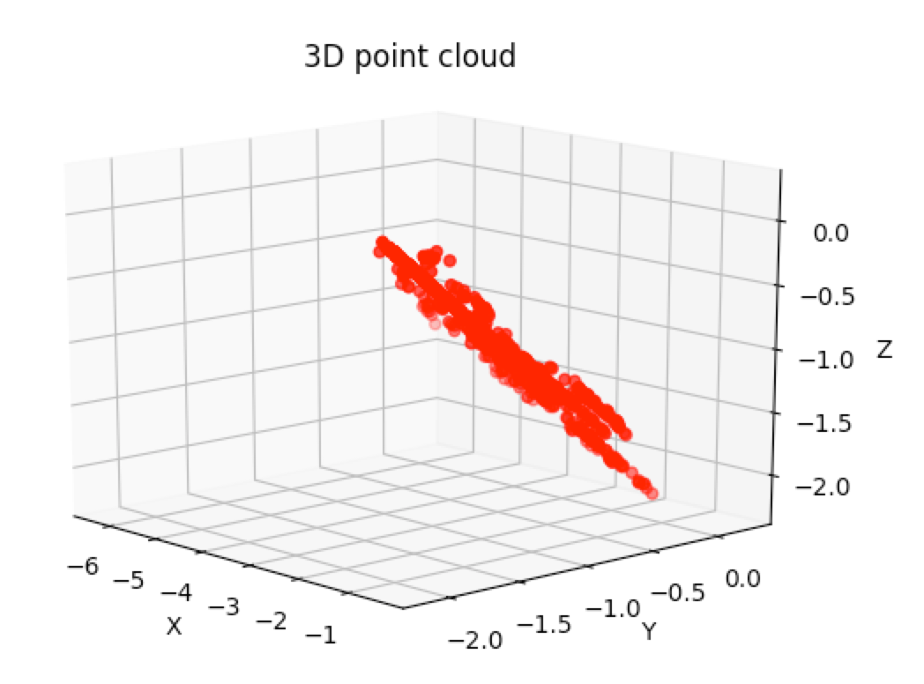

## Left Side Camera (View 2)

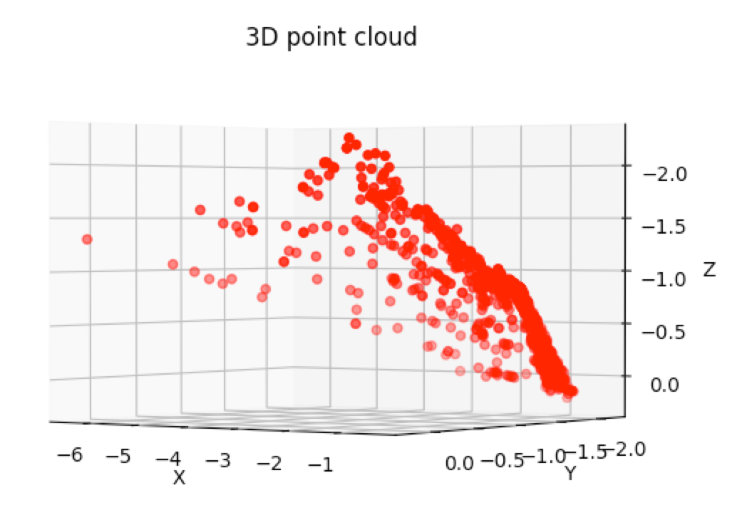

## Top View

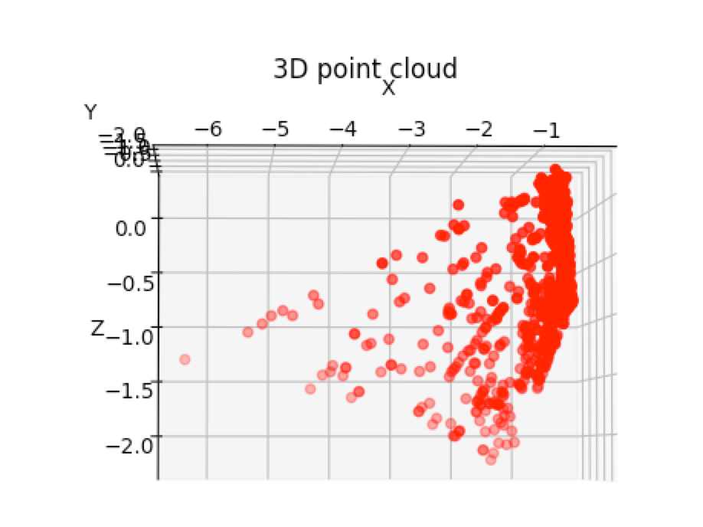

## Center View

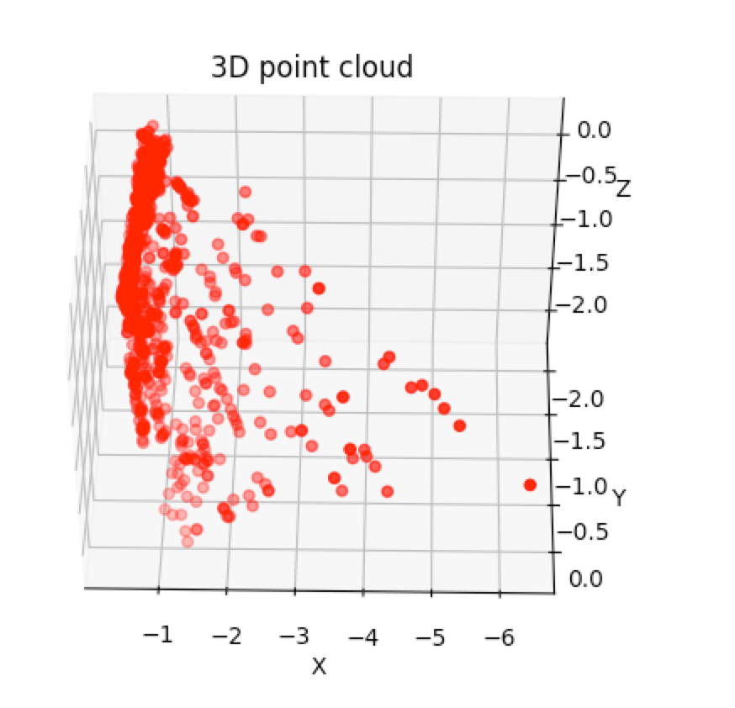

# My Comments

The algorithm performs pretty well. The points to support this statement are

- Clearly most of the points that lie on the same plane, namely the wall behind the fountain, and that the fountain itself extends from that wall in negative z coordinates and shown in the diagrams.

* Similar x coordinates corresponds to the wall behind the fountain
* Between z coordinates from -0.5 to -1.0, the x coordinate is significantly different. almost act as outliers, which shows different keypoints that belong to the surface of the fountain.

# References Used

1. Wikipedia.com
2. OpenCV official website.
3. OpenCV: Computer Vision Projects with Python by Joseph Howse
4. github.com to find utilities to plot 3D points using matplotlib

# Code (with step wise comments)

__author__ = **'deepika'***#https://github.com/FantasyChen/LinearSFM/blob/30f38eca86cd28544829160d9a1249ea43c2c84f/SIFT_matching.py***import** cv2  
**import** matplotlib  
matplotlib.use(**'TKAgg'**)  
  
**import** matplotlib.pyplot **as** plt  
**import** numpy **as** np  
**from** mpl_toolkits.mplot3d **import** Axes3D  
  
*#Define global variables here*Fmask = None  
F = None  
focal=2760/4  
principle=(1520/4, 1006/4)  
K = np.matrix([[focal, 0, principle[0]], [0, focal, principle[1]], [0, 0, 1]])  
K_inv = np.linalg.inv(K)  
  
**def** to_gray(color_img):  
 gray = cv2.cvtColor(color_img, cv2.COLOR_BGR2GRAY)  
 **return** gray  
  
**def** gen_sift_features(gray_img):  
 sift = cv2.xfeatures2d.SIFT_create()  
 kp, desc = sift.detectAndCompute(gray_img, None)  
 **return** kp, desc  
  
**def** read_images():  
 **return** cv2.imread(**'image1.jpg'**), cv2.imread(**'image2.jpg'**)  
  
**def** run_knn_matcher(kp1, desc1, kp2, desc2):  
 bf = cv2.BFMatcher() *# Brute-Force Matcher (FLAAN matcher is an alternative)* matches = bf.knnMatch(desc1, desc2, k=2)  
 good = []  
 pts1 = []  
 pts2 = []  
 **for** m, n **in** matches:  
 **if** m.distance < 0.7 * n.distance:  
 good.append(m)  
 pts2.append(kp2[m.trainIdx].pt) *#Right* pts1.append(kp1[m.queryIdx].pt) *#left* pts1 = np.float32(pts1)  
 pts2 = np.float32(pts2)  
 **return** pts1, pts2, good  
  
**def** auto_points(kp1, desc1, kp2, desc2):  
 bf = cv2.BFMatcher() *# Brute-Force Matcher (FLAAN matcher is an alternative)* matches = bf.knnMatch(desc1, desc2, k=2)  
 good = []  
 **for** m, n **in** matches:  
 **if** m.distance < 0.7 * n.distance:  
 good.append((m.trainIdx, m.queryIdx))  
  
 *#naxN = max([x[1] for x in good])* auto_pts1 = np.zeros((1,len(good),2))  
 auto_pts2 = np.zeros((1,len(good),2))  
 **print "Initially: "**, auto_pts1.shape, **"kp1: "**, len(kp1), **"kp2: "**, len(kp2)  
  
 **for** idx **in** range(len(good)):  
 match = good[idx]  
 **if** match[1] < len(kp2):  
 auto_pts1[0, idx, :] = kp1[match[0]].pt  
 auto_pts2[0, idx, :] = kp2[match[1]].pt  
  
 **return** auto_pts1, auto_pts2  
  
  
**def** apply_homography(src_pts, dst_pts, matches, source, source_kp, destination, destination_kp):  
  
 H, status = cv2.findHomography(src_pts, dst_pts, cv2.RANSAC, 4.0)  
 matchesMask = status.ravel().tolist() *#convert numpy nd.array to List* h, w = source.shape[0], source.shape[1]  
 pts = np.float32([[0, 0], [0, h - 1], [w - 1, h - 1], [w - 1, 0]]).reshape(-1, 1, 2)  
 dst = cv2.perspectiveTransform(pts, H)  
 destination = cv2.polylines(destination, [np.int32(dst)], True, 255, 3, cv2.LINE_AA)  
  
 drawParameters = dict(matchColor=(0, 255, 0), singlePointColor=None, matchesMask=matchesMask, flags=2)  
  
 img3 = cv2.drawMatches(  
 source, source_kp,  
 destination, destination_kp,  
 matches, None, **drawParameters)  
  
 **return** img3  
  
**def** find_essential_matrix(pts1, pts2, focal, principle):  
 **return** cv2.findEssentialMat(pts1, pts2, focal, principle)  
  
**def** decompose_essential_matrix(ess_matrix, matches, first_key_points, second_key_points):  
  
 first_match_points = np.zeros((len(matches), 2), dtype=np.float32)  
 second_match_points = np.zeros_like(first_match_points)  
 **for** i **in** range(len(matches)):  
 first_match_points[i] = first_key_points[matches[i].queryIdx].pt  
 second_match_points[i] = second_key_points[matches[i].trainIdx].pt  
  
 match_pts1 = first_match_points  
 match_pts2 = second_match_points  
  
 **global** Fmask, K_inv  
 U, S, Vt = np.linalg.svd(ess_matrix)  
 W = np.array([0.0, -1.0, 0.0, 1.0, 0.0, 0.0, 0.0, 0.0,  
 1.0]).reshape(3, 3)  
  
 *# iterate over all point correspondences used in the estimation of the  
 # fundamental matrix* first_inliers = []  
 second_inliers = []  
 **for** i **in** range(len(Fmask)):  
 **if** Fmask[i]:  
 *# normalize and homogenize the image coordinates* first_inliers.append(K_inv.dot([match_pts1[i][0],  
 match_pts1[i][1], 1.0]))  
 second_inliers.append(K_inv.dot([match_pts2[i][0],  
 match_pts2[i][1], 1.0]))  
 *# option 1  
 #R = U.dot(W).dot(Vt)  
 #T = U[:, 2]  
  
 # option 2* R = U.dot(W).dot(Vt)  
 T = - U[:, 2]  
  
 *# option 3:  
 #R = U.dot(W.T).dot(Vt)  
 #T = U[:, 2]  
  
 # option 4:  
 #R = U.dot(W.T).dot(Vt)  
 #T = - U[:, 2]* match_inliers1 = first_inliers  
 match_inliers2 = second_inliers  
 Rt1 = np.hstack((np.eye(3), np.zeros((3, 1))))  
 Rt2 = np.hstack((R, T.reshape(3, 1)))  
  
 **return** match_inliers1, match_inliers2, Rt1, Rt2  
  
**def** draw_lines(img_left, img_right, lines, pts_left, pts_right):  
 h,w = img_left.shape[0],img_left.shape[1]  
 img_left = cv2.cvtColor(img_left, cv2.COLOR_GRAY2BGR)  
 img_right = cv2.cvtColor(img_right, cv2.COLOR_GRAY2BGR)  
  
 **for** line, pt_left, pt_right **in** zip(lines, pts_left, pts_right):  
 x_start,y_start = map(int, [0, -line[2]/line[1] ])  
 x_end,y_end = map(int, [w, -(line[2]+line[0]*w)/line[1] ])  
 *#color = tuple(np.random.randint(0,255,2).tolist())* color = (204,255,0)  
 *#print "Value of color: ", color* cv2.line(img_left, (x_start,y_start), (x_end,y_end), color,3)  
 cv2.circle(img_left, tuple(pt_left), 5, color, -1)  
 cv2.circle(img_right, tuple(pt_right), 5, color, -1)  
  
 **return** img_left, img_right  
  
**def** display_epipolar_lines(pts_left_image, pts_right_image, img_left, img_right):  
  
 **print "Initialized F"  
 global** F, Fmask  
 F, Fmask = cv2.findFundamentalMat(pts_left_image, pts_right_image, cv2.FM_LMEDS)  
 take_top = 100  
 *# Selecting only the inliers* pts_left_image = pts_left_image[Fmask.ravel()==1]  
 pts_right_image = pts_right_image[Fmask.ravel()==1]  
  
 lines1 = cv2.computeCorrespondEpilines(pts_right_image.reshape(-1,1,2), 2, F)  
 lines1 = lines1.reshape(-1,3)  
 lines1 = lines1[0:take_top]  
 img_left_lines, img_right_pts = draw_lines(img_left, img_right, lines1, pts_left_image, pts_right_image)  
  
 *# Drawing the lines on right image and the corresponding feature points on the left image* lines2 = cv2.computeCorrespondEpilines(pts_left_image.reshape(-1,1,2), 1,F)  
 lines2 = lines2.reshape(-1,3)  
 lines2 = lines2[0:take_top]  
 img_right_lines, img_left_pts = draw_lines(img_right, img_left, lines2, pts_right_image, pts_left_image)  
  
 cv2.imwrite(**'Epi lines on left image.jpg'**,img_left_lines)  
 cv2.imwrite(**'Feature points on right image.jpg'**,img_right_pts)  
 cv2.imwrite(**'Epi lines on right image.jpg'**,img_right_lines)  
 cv2.imwrite(**'Feature points on left image.jpg'**,img_left_pts)  
  
 **print "=------Done with epipole lines=-----"  
  
def** startSift():  
  
 *#Step 1:  
 # Read the image files and find SIFT features.* source, destination = read_images()  
 **print "Read imaged: "**, type(source), source.shape  
  
 *#Step 2:  
 # Figure out local matches* source_gray = to_gray(source)  
 destination_gray = to_gray(destination)  
  
 source_kp, source_desc = gen_sift_features(source_gray)  
 destination_kp, destination_desc = gen_sift_features(destination_gray)  
 **print "Number of keyPoints found: "**, len(source_kp)  
  
 img = cv2.drawKeypoints(source_gray, source_kp, source)  
 cv2.imwrite(**'KeyPointsMatchBeforeHomography.jpg'**,img)  
  
 src_pts, dst_pts, matches = run_knn_matcher(source_kp, source_desc, destination_kp, destination_desc)  
  
 *#Step 3:  
 # Run for global matches. That is homography* global_match_img = apply_homography(src_pts, dst_pts, matches, source, source_kp, destination, destination_kp)  
 cv2.imwrite(**'KeyPointsMatchAfterApplyingHomography.jpg'**,global_match_img)  
  
 *#Step 4:  
 # Display Epipolar lines* **print "-----------starting Epipolar lines"** display_epipolar_lines(src_pts, dst_pts, source_gray, destination_gray)  
  
 *#Step 5:  
 # Find Essential Matrix* ess_matrix, mask = find_essential_matrix(src_pts, dst_pts, focal, principle)  
 **print "Essential Matrix from openCv function: "**, ess_matrix  
  
 *#Step 6:  
 # Decompose Essential Matrix* match_inliers1, match_inliers2, Rt1, Rt2 = decompose_essential_matrix(ess_matrix, matches, source_kp, destination_kp)  
 **print "Step 5 results:"  
 print "Rt1: "**, Rt1  
 **print "Rt2: "**, Rt2  
  
 *#Step 7:  
 # Triangulate* first_inliers = np.array(match_inliers1).reshape(-1, 3)[:, :2]  
 second_inliers = np.array(match_inliers2).reshape(-1, 3)[:, :2]  
 pts4D = cv2.triangulatePoints(Rt1, Rt2, first_inliers.T, second_inliers.T).T  
  
 *# convert from homogeneous coordinates to 3D* pts3D = pts4D[:, :3]/np.repeat(pts4D[:, 3], 3).reshape(-1, 3)  
  
 *# plot with matplotlib* Ys = pts3D[:, 0]  
 Zs = pts3D[:, 1]  
 Xs = pts3D[:, 2]  
  
 fig = plt.figure()  
 ax = fig.add_subplot(111, projection=**'3d'**)  
 ax.scatter(Xs, Ys, Zs, c=**'r'**, marker=**'o'**)  
 ax.set_xlabel(**'X'**)  
 ax.set_ylabel(**'Y'**)  
 ax.set_zlabel(**'Z'**)  
 plt.title(**'3D point cloud'**)  
 plt.show()  
 raw_input(**">Hit Enter To Close"**)  
 plt.close()  
  
startSift()